**CREATING AN INTRICATE eLEARNING APPLICATION IN A COVID WORLD: WILL BAGPIPE MUSICAL THEORY ONLINE REVOLUTIONISE THE GLOBAL MARKET FOR LEARNING COMPLEX MUSIC NOTATION?**

**Abstract:**

This study investigates how an eLearning application for bagpipe musical theory will enhance student learning. Research has shown that process the number of eLearning applications has increased due to Covid ensuring the safety of others. Therefore, the need for an application that will teach complex music notation for the bagpiping community must be developed. The aim is to determine that eLearning applications can convey the complexities of bagpipe music theory teaching techniques to a global audience. Based on research involving bagpipe music theory and applications, this literature review asks; *creating an intricate eLearning application in a Covid world: will bagpipe musical theory online revolutionise the global market for learning complex music notation?*

The software will be used to plan, design, and develop this application while considering the intricate processes that are involved in the creation of the application including complex music notation and pronunciation. The application aims to enhance the online presence of bagpipe musical theory and encourage students in a modern environment which caters to Covid restrictions.

**Keywords:**

Covid, Bagpipe, Application, Design, Process.

**Name: Lewis Maitland**

**Matriculation Number: 2006614**

**Course: CM4105: Honours Project**

**Email: l.maitland1@rgu.ac.uk**

**Contents**

**1. Introduction** 3

**1.1 Introduction to applications** 3

**1.2 Introduction to Bagpipe Music Theory** 4

**1.3 Concept idea – Old vs New** 4

**1.4 Project scope** 5

**2. Themes:** 6

**2.1 Learning Techniques:** 6

**2.2 Music Notation** 6

**2.3 Canntaireachd** 9

**2.4 Intricate processes** 10

**3. Development:** 12

**3.1 Software** 12

**3.1.1 Adobe Illustrator** 12

**3.1.2 Adobe After Effects** 13

**3.1.3 Adobe XD** 14

**3.1.4 Adobe Audition** 15

**3.1.5 Adobe Media Encoder** 15

**3.1.6 Unity** 16

**3.1.7 Visual Studio Code** 17

**3.1.8 Microsoft Word** 18

**3.2 Design & Planning** 19

**3.2.1 Mood Boards** 19

**3.2.2 Story Boards** 20

**4. Background Information:** 21

**4.1 Design Background** 21

**4.2 Practice Background** 21

**4.3 Methodological Background** 22

**4.4 Geographical Background** 23

**4.5 Literacy Background** 24

**5. Conclusion:** 25

**References:** 26

# **1. Introduction**

## **1.1 Introduction to applications**

Applications have been a modern solution to an ever-growing and developing society with unique problem-solving characteristics, from games to learning. This invention has capitalised on the global market allowing users to be entertained, learn a new language, create, and share new ideas across social media. The Covid Pandemic created a surge of new applications due to more people working from home and self-isolating as required by governments to keep people safe. Therefore, a spike in internet usage has increased by “between 50% and 70%”(Beech, M. 2020)[1] during the Covid Pandemic, with “184563 apps released in the time window of July 2019-May 2020” (Samhi, J. Allix, K. Bissyande, T.F. & Klein, J. 2021)[2] in Google Play alone. With a focus on education and health, demand for new and intricate learning applications is required to create an online approach within this Covid World.

The timescale for application development is a long process as multiple elements are required to design, create, and maintain applications for the global market. All applications are designed in similar formats:

* Planning stage using Business Analysis to extract the relevant market research;
* Application Design stage which will create User Experience and User Interface design;
* Application Development to create all elements of the application structure including back-end development, front-end development and testing then launching the product;
* Finally, an ongoing process of Support, Maintain and Update accordingly based on real-world client information.

This methodology is beneficial to its overall success, as stated by Existek 2019, “Complex and sophisticated apps will need 40+ weeks of development depending on the scale of the project and ambitions of the business” [3] (see Figure 1). Applications are therefore built to be relevant and reliable sources of information, promote operability, and maximise intelligent interface.

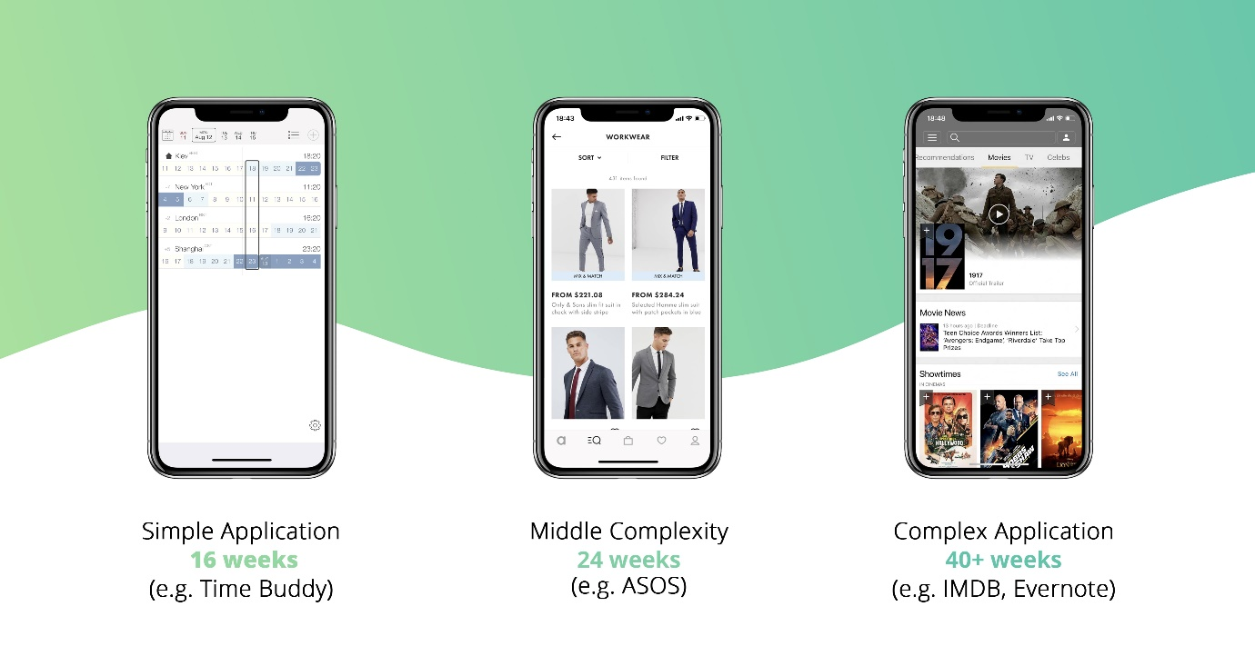

Figure 1: Difference between timescale of applications[1]

## **1.2 Introduction to Bagpipe Music Theory**

Music theory is one of the main concepts in learning any musical instrument. Music breaks down into two components, practical and theory. In practical teaching, an individual will be shown the instrument, how to play it, hold it and start the learning process. Music theory (or music notation) is the written form of music and is essential to allow the player to create, perform and learn effectively. With the complexity of learning bagpipe music theory, students will need to learn the main components of music notation and how to pronounce, read and recognise each note and embellishments using Canntaireachd (pronounced – “can-ter-acht”). Earliest published a tutorial on bagpipe music theory was “as early as 1760”(Bissell, C. 2017)[2] using a complex language within bagpipe music, Canntaireachd the earliest method of teaching bagpipe notation.

## **1.3 Concept idea – Old vs New**

The dynamic of creating a new bagpipe music theory application will create multiple paths for the bagpiping community. Pre Covid, most instructors would teach music theory in person, either at a school or face to face, allowing for interactive and immediate communication between teacher and student. This style of teaching has been passed down through generations, ideas for revolutionising learning musical theory included flashcards which one side of the card would have the note as presented on sheet music, while on the other side the name of the note(s) would appear and pronunciation for that note in Canntaireachd. The application would recreate this flashcard technique and become available on users’ mobile devices, allowing the user to continually learn outside of the lesson and provide an alternative interactive learning platform. While Covid is still present within day-to-day life, all parties must ensure that they stay as safe as possible, therefore the need for this application is more relevant. This application will, however, not appeal to all users, for example, most bagpipe teachers would prefer to use the techniques they have been taught and passed down from generation to generation. Since most of the sheet music and books about bagpipe musical theory is in book form, this can lead to difficulties within the online community who would need an alternative. This application, therefore, allows students a choice and a complementary approach to their music notation theory learning.

## **1.4 Project scope**

Musical theory and how it has been taught and implemented has been a world-renowned process within the bagpipe communities for generations, multiple theories have been proposed to explain and analyse the importance of this and how to implement it properly. This literature will cover the main supporting theories for this question and focus on the four themes which will be implemented throughout this review. The themes include

* Intricate design processes to create the application;
* Adapting music notation for mobile applications;
* Implementing Canntaireachd within an online learning application;
* Appealing modern-day learning technology to all generations.

This literature review will analyse and focus on these themes while ensuring that the concept of creating an eLearning application for Bagpipe Music theory is possible.

# **2. Themes:**

## **2.1 Learning Techniques:**

To become proficient in playing the bagpipe, students start learning with a smaller version of the bagpipe known as the practice chanter. Students focus initially on the nine-note scale, blowing into the chanter to provide a steady tone, and successfully playback using the chanter the nine notes as shown in scale exercises. During this introduction stage, students will also learn the importance of music theory and pronouncing individual notes using an ancient technique known as Canntaireachd. This process may take students a few weeks to learn, while others can take longer to fully understand the music theory and must learn from it. Most instructors will have the name of the note’s underneath them as well as other guides and charts that allow the student to understand what wholes to cover on the chanter to play the note.

Each time an instructor provides their student with a new exercise or tune, the student will be continually learning the basic notes in a new order. The instructor will demonstrate how each note is played, including finger positioning. Every student is different and instructors constantly adjust their teaching techniques to ensure individual students learn properly and efficiently. Pre-Covid, most of the lessons were one to one, allowing for continuous support with all aspects of teaching. Any question that a student may need answering will be shown step by step in person. This process is key for students to see exactly how they can properly handle the chanter positioning and properly sound each note.

However, due to the Covid pandemic, instructors must now teach over the phone or video calls such as Microsoft Teams or Skype. These techniques for teaching caused complications with students, factors including unstable Wi-Fi connection, poor audio quality, and difficulty with adapting to a new system of teaching of muting and unmuting calls to ensure students can play at the same time, which is not ideal for instructors who need to hear how their student is playing. Within this Covid pandemic, learning techniques have become more complicated as the instructor must incorporate safe teaching, ensuring both individuals are safe to practice and follow Covid guidelines. Therefore, teaching styles will need to be flexible with the global market changing to become more online friendly. This application will provide this bridge and ensure students receive professional lessons remotely.

## **2.2 Music Notation**

All instruments, including the bagpipe, utilise music notation or sheet music as it is the backbone in learning and playing music, an example of which is shown in Figure 2 displayed and created on applications like Bagpipe Music Writer Gold. This software was created in 1999 by Robert MacNeil Musicworks, to create sheet music using unique coding skills to fully create sheet music. Within this software, users can recreate music from books manually, play it back to the user and can share the music with others. This application was revolutionary and is still popular to this day, other updated versions have appeared on the market, but the software is quite complex as each tune needs to be crafted using online guides to complete. Obtaining this software is currently only possible via paying for it, which is expensive more most users, and can be obtained from passing down the software and installing it manually. Bagpipe Music Writer Gold is a tool for learning music for the bagpipes however due to how it is programmed most phrasing, i.e., how notes are held or emphasised within playing the music, is mathematically calculated as per the code it is based upon. Therefore, users must either use it as a guide or fully edit the tune using the complex coding system to allow the software to play the tune as it should be, but the appearance of the sheet music is false as per how it should be written. This software was ideal when the Covid pandemic arrived, but due to its complexity, most students were not advised to use this alternative to teaching without the proper training.

For learning music notation, Bagpipe Music Writer Gold is good for older generations who have the knowledge and can pass on the information accordingly, however, most instructors would prefer one to one instruction with their students. With an application, each note would appear on the user’s screen clearly and there the user can continually learn each note. This method would not replace Bagpipe Music Writer Gold, however, would be an alternative to learning individual notes to then prepare students for full music notation.

Figure 2: Bagpipe Music Notation Example created in Bagpipe Music Writer

## **2.3 Canntaireachd**

Before standard bagpipe music notation, Canntaireachd was the traditional way to learn. In Gaelic, Canntaireachd means singing, this concept for expressing music allowed for pipers to emphasise raw emotion within the tune. This method is a complex and subjective skill to master and awe-inspiring to listen to, as the piper would not only memorise lines of complex dialogue but also take flow and musical interpretation of the tune, consider nuances of each note, and rhythm/pacing of the tune into account. How Canntaireachd is pronounced is inspired by the Campbell Canntaireachd, “a document containing 168 tunes” (McCalister 2021) written 1797 where “each note, gracenote and movement had its own individual sound” (McCalister 2021). This revolutionary concept started the idea of using pronunciation within bagpipe music. In Figure 3, an example of music notation alongside Canntaireachd explores another way of learning music within the bagpipe world. Currently, Canntaireachd is commonly used in Piobaireachd or ‘ceòl mór’, the ancient are of bagpipe music (literally meaning “big music”, as each tune is often over 10 minutes in length and comprises of highly complex intonation and music). It is played competitively in a modern environment and is considered the hardest style of playing where pipers must memorise long tunes and express them like they are singing a song.

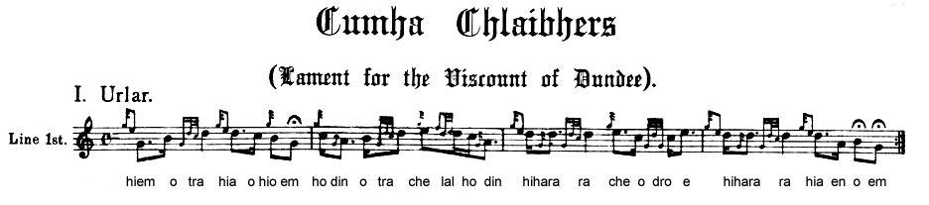

Figure 3: An example of Canntaireachd alongside music notation[3]

All students should understand Canntaireachd when learning the bagpipes. This can be challenging if students are misunderstanding the difference between music notation, how the notes look and sound on the practice chanter, compared to how they could be sung. An application that would both allow the student to understand note values, names, notation, and the pronunciation using Canntaireachd would give more freedom to explore this complex language within bagpipe learning. Using multiple teaching techniques, the application would allow users to listen to the pronunciation of the note in Canntaireachd form, see how it is spelt, while also allowing the students to answer questions that would allow for continual learning. These techniques will be apparent throughout the application and have proven to be effective in similar applications for learning a language. Therefore, using Q&A styled questions, vocal prompts, and repetition; students will have the ability to pick up Canntaireachd easily. This would increase the literacy, language, and vocal skills of students as they continually learn ways to improve their bagpipe musical potential.

## **2.4 Intricate processes**

Creating an eLearning Application for Musical Theory must have an effective, thoughtful design process, ensuring that the intricate processes are well managed and carefully planned out. To create this application, key stages of the design and development process is required for continuation into the project. Researching current design trends within application design, eLearning platforms, and bagpipe website design plays a role in how the design process will be implemented. Without researching these trends and designs, students will not understand the importance of how an application will flow and be perceived for its true functionality. Therefore, researching current and successful applications with flexible end-user feedback is crucial for designing a flexible application. Once further research into application design has been completed, ensuring that the created and prototyped design is intricate and fully functional a step-by-step guide must be carried out to ensure its Functional and Non-functional requirements are met.

For bagpipe music notation, measures for how students can interact with the application must be straightforward, as the target audience for this application will vary. Most students who start at an early age learning to play the bagpipes are between 7-9 years old, therefore ensuring language is understandable, design is appropriate, and flow of the application is tested to allow for younger students to explore the application. To ensure that this application would tailor to all ages and varied experience levels of pipers, the level design must be incorporated into the design process. The application will have multiple levels that can be progressed either one at a time or all at once, as they can be explored anytime that would suit the student and their skill level. Each level would be divided into sections, the type of level, what they will involve, and the experience required for the section. The application will not be locked for users who do not have the experience, but it will advise the student to complete the previous levels. These are detailed below in Table 1.

|  |  |  |
| --- | --- | --- |
| Level Difficulty | Description | Experience required |
| Beginner | This section is recommended for all new learners as this would cover all basic techniques from first exercises to basic music notation.  Focusing on the first 9 notes used in the first scale exercise, how it is pronounced in Canntaireachd, and how to write it in music notation.  Other exercises will be incorporated, recommended tunes will be displayed for the user to learn that will cover the basic techniques. | All – beginners recommended |
| Intermediate | Intermediate level will cover more difficult exercises, tunes and Canntaireachd focused on embellishments.  Focusing on newer embellishments used to play more complicated exercises and tunes. Covering tunes primarily used in most pipe bands, using time signatures such as 2|2; 2|4; 3|4; 4|4; and 6|8; with explanation on what these mean in notation and how they can affect phrasing and pacing.  Also covering types of tunes including slow airs and traditional marches. | All, required to know basic exercises |
| Advanced | Advanced level primarily focuses on integrating techniques used for more complicated tunes. Advanced exercises will be accessible at this stage.  Focusing on tune styles including jigs, hornpipes, competition marches, strathspeys, and reels. | All – required to understand music notation and play tunes. |
| Expert | This section will cover more in-depth music notation used by more professional pipers, while also exploring more Canntaireachd.  Activities within this stage will focus more on writing out Canntaireachd and testing the student on new and previous notations. | All – must have more experience within piping world. Recommended for students with 5+ years’ experience (this may vary). |
| Piobaireachd | Piobaireachd will only cover all elements used within this complicated tune styling. Focusing more on Canntaireachd, primarily used to express the music notation.  Continuing the teach more exercises only applicable to Piobaireachd. | All – Recommended for more advanced students or for students who have a passion for Piobaireachd. |

Table 1: Table explaining level design within the application

# **3. Development:**

## **3.1 Software**

During this project, creating an application will require intricate software to manage how the project is processed, create detailed designs, create components that will be implemented into the project, develop the application, and promote the product. In this section, each software will be discussed in detail of its function within the project, reflecting on its overall performance and how it will be key for the creation of this Bagpipe Music Theory Application.

### **3.1.1 Adobe Illustrator**

This application is to create vector graphics vital in the creation of any application as this will be the main foundation for key components such as buttons, logos, and icons. Adobe Illustrator will create the sprites used to create the application, the music notation such as gracenotes, individual notes, and Canntaireachd pronunciation will be created with the design tools built into this software. This will provide the application with high-quality graphics that can be edited correctly then implemented into the application. These icons will follow the main design based around bagpipe music notation and therefore will be designed to be clear and recognisable by the students. The advantages of this software stem from the ability to transfer and create designs and implement them in multiple Adobe software as it uses the cloud to transfer and share components. Disadvantages such as being expensive and having constant updates can become a major factor in application development, however, the advantages outweigh the negatives of using this software.



Figure 4: Adobe Illustrator used for creating logos and other components[4]

### **3.1.2 Adobe After Effects**

Adobe After Effects software creates videos using drag and drop methods capable of creating high-quality videos. At the end of the project, a video displaying the completed application will be created using After Effects, highlighting the main functionality of the bagpipe music theory application. Also creating multiple short introduction videos used as tutorials on the application itself and creating advertisement friendly videos used to promote the product for the global market. These tutorials will demonstrate to the student the position of the fingers on the practice chanter and recreate the sound of a particular note or embellishment. As this software is run by Adobe, After Effects can achieve complex editing, use plugins that would elevate the video and have a multitude of helpful tutorials online which can accommodate any project. However, this software can run into RAM, Random-access memory, issues due to the size of any project; may cause crashes as per the size of the project or difficulties with other plugins. Videos of the final design and pitch for the project will be created using this advanced software.

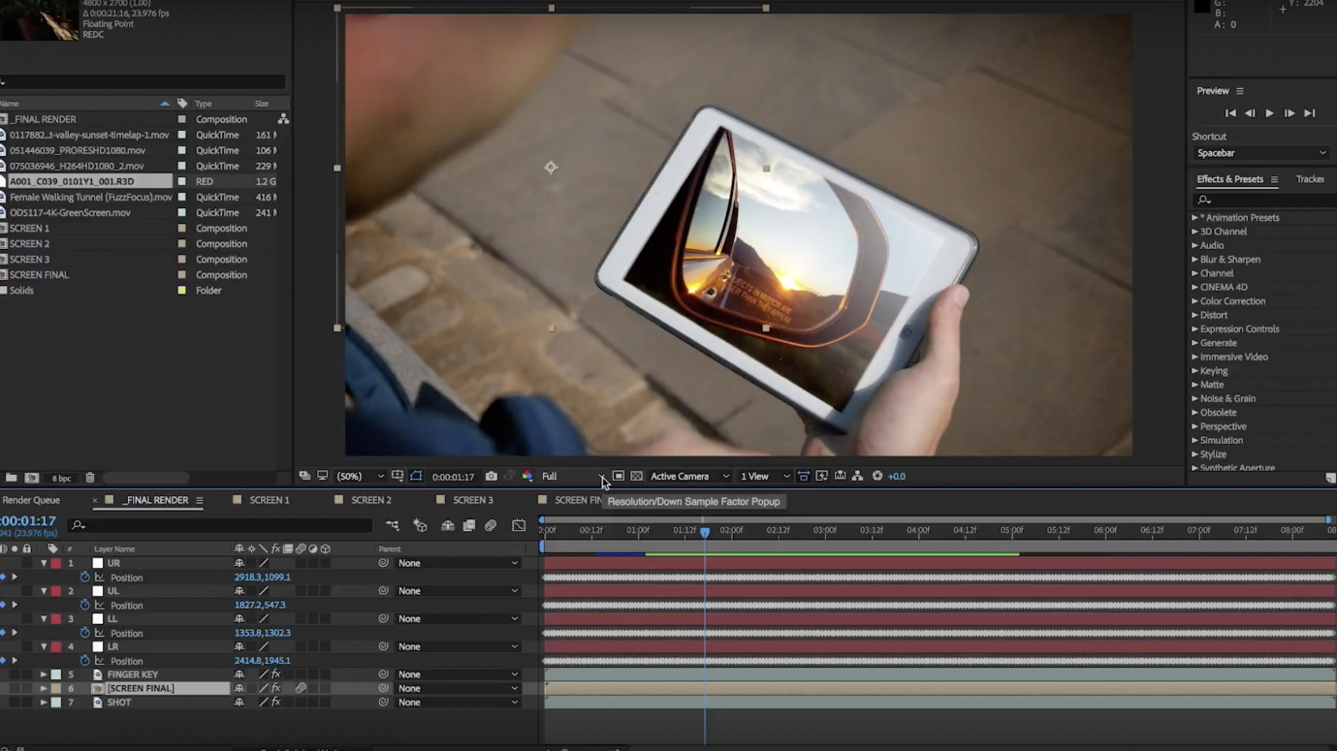

Figure 5: Adobe After Effects used for creating videos[5]

### **3.1.3 Adobe XD**

Adobe XD or Adobe Experience Design is a design platform, creating designs and templates based on the User Experience (UX) design tool, allowing the designer to create plans, wireframes and prototypes of applications, games, or websites. The design tools this software can offer will create the wireframes, storyboards, and prototypes for the applications, using drag and drop techniques to plan the design of the application. Displaying how each section will work, the flow between each section for example loading screen to selection screen. As displayed in Figure 6, the designs of the bagpipe music application will be displayed in a similar format as the image, designed will be the accurate representation of the result. With its straightforward design layout, in-depth tutorials, and the ability to create fully working applications within the ‘preview’ mode that would allow a developer to fully utilise the design and implement it. Smaller issues including custom designed shapes from plugins cannot be edited properly, command shortcuts can cause the software to freeze, and the prototyping phase requires ongoing support with tutorials. Adobe XD will be the primary use of creating designs and prototypes for the application along with other aspects of the project such as mood boards and storyboards.

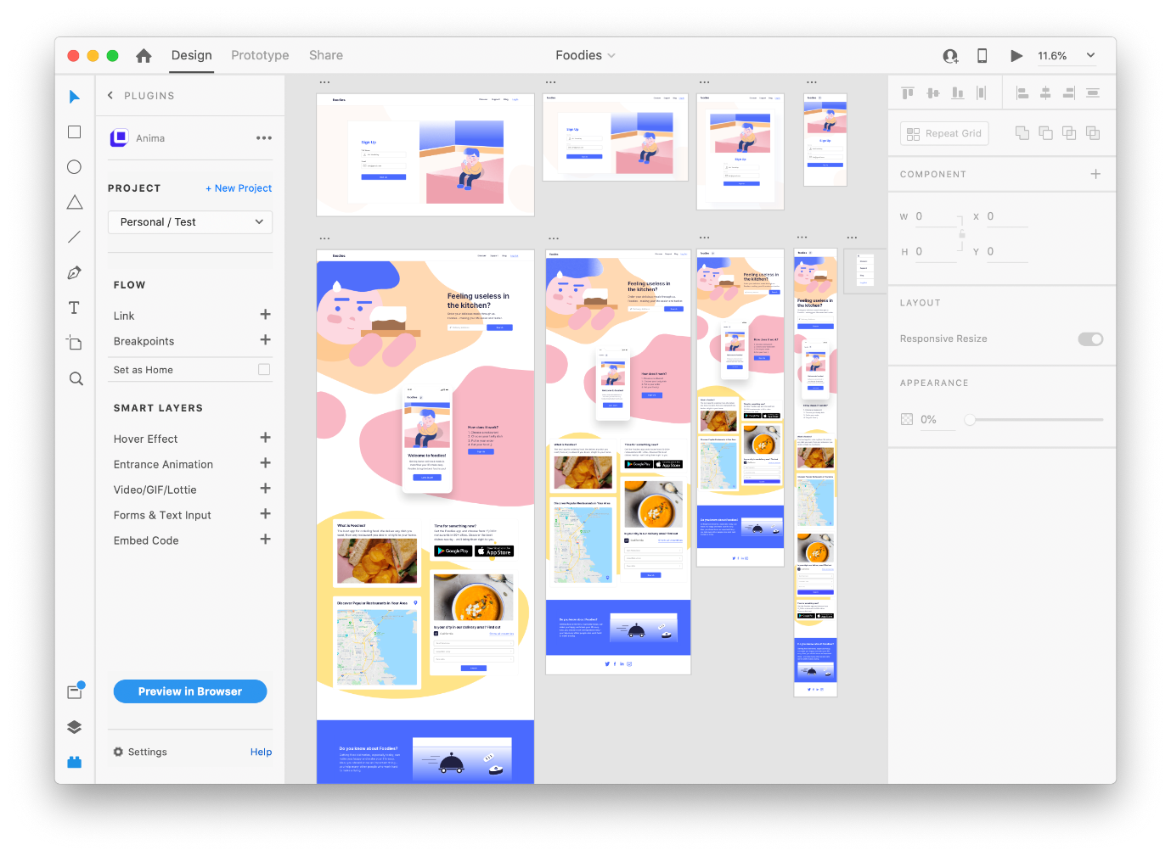

Figure 6: Adobe XD used for creating templates and prototypes[6]

### **3.1.4 Adobe Audition**

Adobe Audition is the primary method for recording and editing sounds, integrating with other adobe software to allow for quick transitioning between sound editing, allowing for quick and creative results. When creating an application that requires sound to function. High-quality recordings are required for this project as this eLearning application will require sound to ensure students can learn properly. Since this application focuses on bagpipe notation, recordings of the instructors/designer’s voice and bagpiping will be required to ensure that the application runs smoothly. Using Adobe Audition records sound effects with its built-in features for enhancing the audio quality, editing how it sounds, increasing the sound waves of the sound while ensuring that the performance level increases with each change. However, this software can be tricky to understand with its complex unnecessary settings and how the layout structure is set out, as without tutorial guidance this interface can be difficult to navigate. When creating an application using Canntaireachd and bagpipe music, good quality sound is required to ensure the end-user can understand what is being heard as this will be the key component for creating the application.

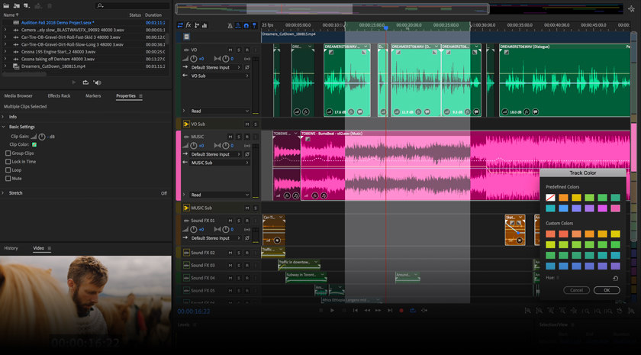

Figure 7: Adobe Audition used for editing and recording sounds[7]

### **3.1.5 Adobe Media Encoder**

Adobe Media Encoder is a software that is needed to extract and encode video files, used for partnering software such as Adobe After Effects or Adobe Premiere Pro, as well as uploading videos and changing their format to images, mp3 or gifs. Media Encoder will allow for bagpipe videos that will have a high quality of sound and performance format to change from mp4 to mp3 while ensuring that any completed videos created in supporting software can be created. Other videos can be converted into still images, this would generate multiple high-quality images taken from each frame in the video. Therefore, images of a bagpiper marching can be cut out of the video and implemented into the application as an image. This software is free with the pairing software as mentioned, this allows for ease of use, steady process and allowing multiple files to be converted at one time. Rendering can cause an issue with how long this may take to implement; to ensure the maximum quality, speed, and potential of the software the developer’s hardware must be high end. In function with Adobe After Effects, this software will be required to ensure video formatting is successful.

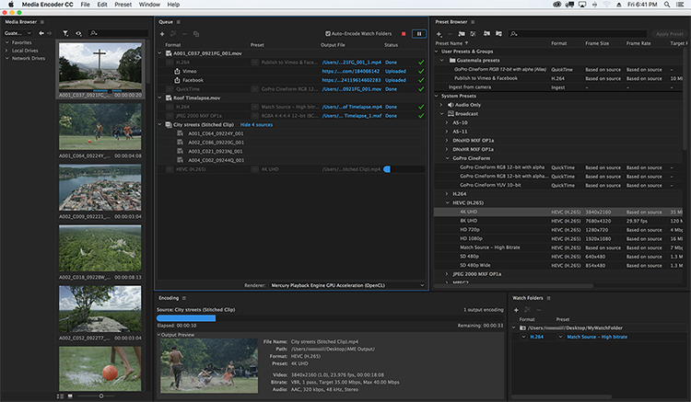

Figure 8: Adobe Media Encoder used for exporting and changing file types[8]

### **3.1.6 Unity**

Unity is development software that allows for the creation of 3D and 2D games and apps, with the ability to utilise C# scripting for implementing game styled scenarios and systems, creating environments as well as the structure of the game and importing multiple icons, character models or sound scripts allows for ease of use and effective implementation. Creating an application that can be used on multiple devices is important to ensure this music application can be accessed globally. The application will be fully created using Unity while all the resources from other software will be implemented, Unity will create all the functionalities, playability and display the full creation of the application. Flexible development that allows developers to create applications and games for multiple platforms from Windows and Xbox to Oculus Rift and iOS. Allowing for cross-platform development, access to create and develop high-quality graphics for all systems. When creating any application or game with this software issues with potential lag or crossing between different foundations can result in difficulties when creating any application. Unity will be the main application in creating the intricate eLearning application for this Bagpipe Musical Theory project.

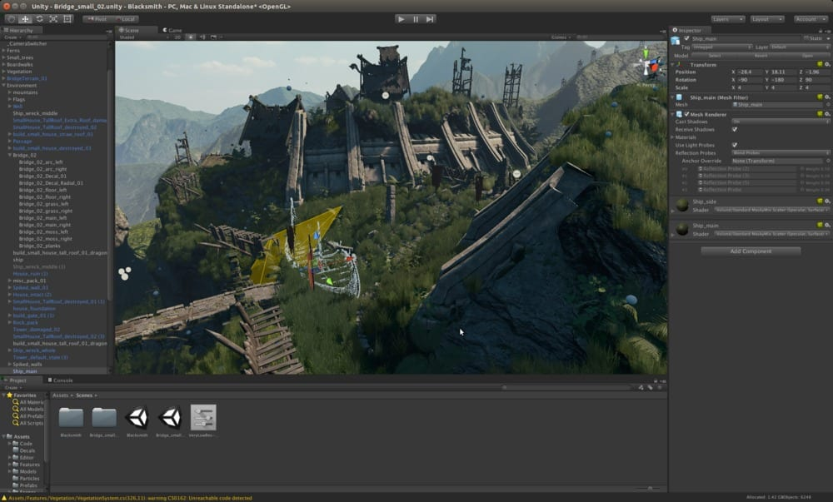

Figure 9: Unity used for creating games and applications[9]

### **3.1.7 Visual Studio Code**

Visual Studio Code is software designed for editing and creating code for scripts built into unity, using C#, JavaScript, and other coding techniques; this software allows developers to create game engines and mechanics within Unity. To create the code required for application management, storing information, flowing to each page, and all functions within the application will be created using this software. The use of extensions provided by the software can allow for creating and editing code to be simplified, the quick and understanding User Interface (UI) is easily accessible and rememberable for all designers. The built-in machinic that allows users to show the folder structure within their computer system and then create other folders and scripts within Visual Studio Code itself is an asset for creating code easily. The issue of high Central Processing Unit (CPU) usage can cause the software to freeze or crash over time, and the integrated support with code for finding errors within it can lead to issues during script updating within Unity. This software will be continuously used to create the scripts within Unity as the primary function.

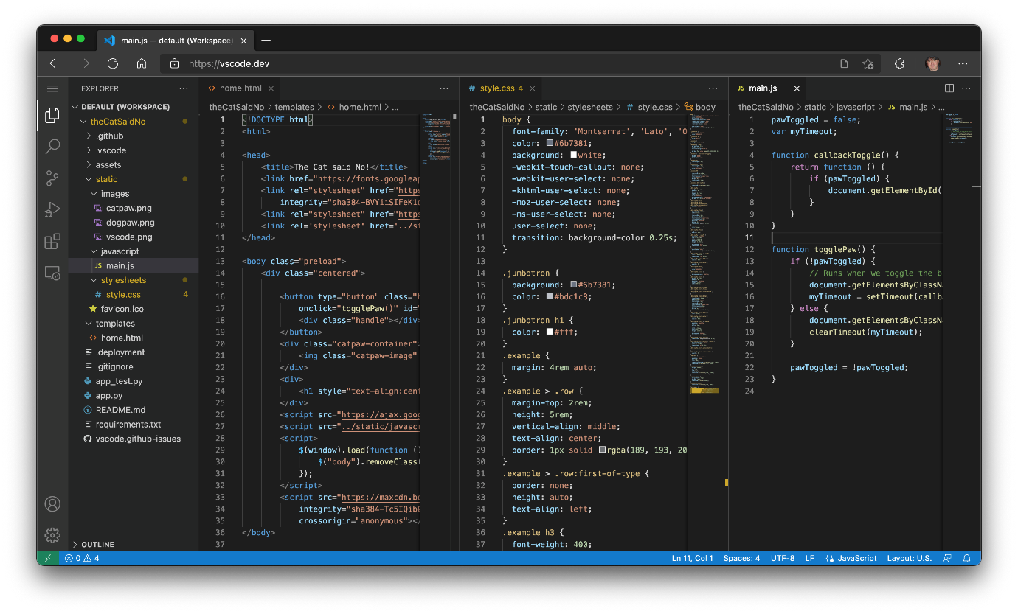

Figure 10: Visual Studio Code used for creating and editing scripts for Unity[10]

### **3.1.8 Microsoft Word**

Microsoft Word software is primarily used for creating documentation, editing important information and presenting data in multiple ways, from using tables, inserting images, or designing research papers. All documentation that will be completed during the project, including testing documents, evaluation and reflection, planning, and design, will be completed using Microsoft Word. This software is simple to use, able to implement fonts through installation on the developer’s computer and the use of multiple design techniques to expand documents. Settings such as automatic formatting and autocorrecting can be useful in most circumstances when creating any documentation, however, when trying to create documentation in an expressive design this automatic format can cause issues. This software will be the primary use of creating design documents, evaluation papers and reflective accounts.

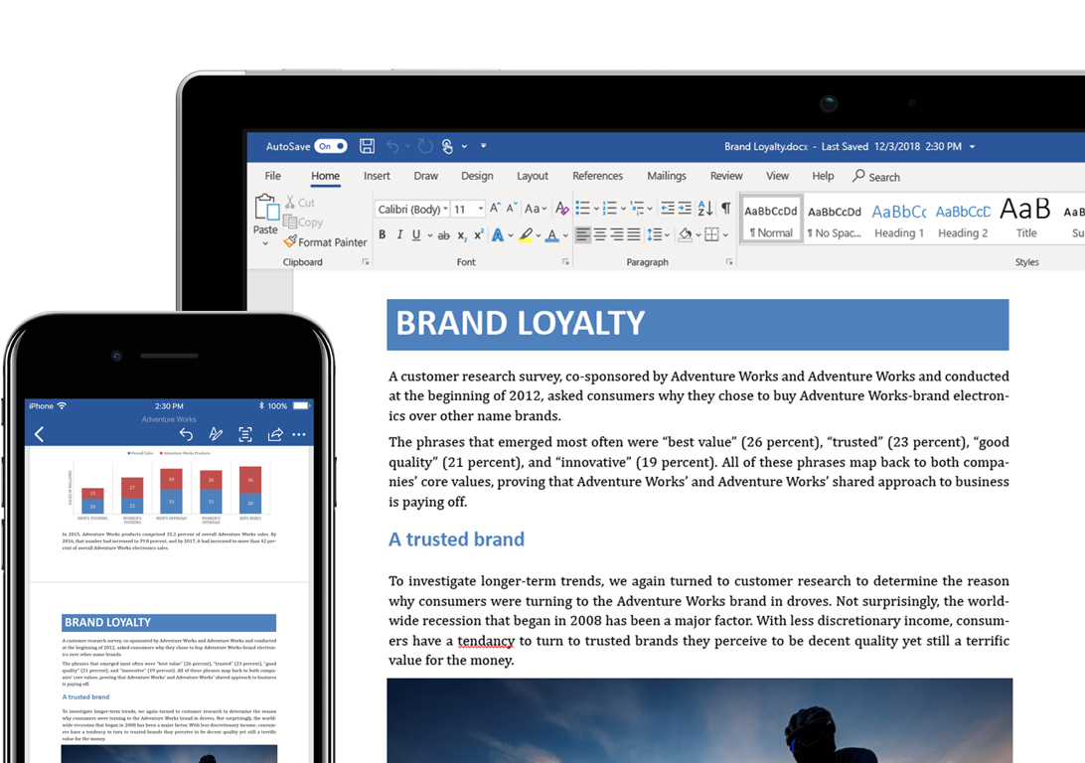

Figure 11: Microsoft Word used for creating documentation[11]

## **3.2 Design & Planning**

In this project the design and planning phase is an important concept in the creation of any application, with a project as complicated as a Bagpipe Musical theory application, this must be carefully examined to determine the best possible approach to ensure success. Within this next section, how the project will be designed and planned will be explained using the following methods: using mood boards, storyboards, and creating an application development plan.

### **3.2.1 Mood Boards**

When planning for a concept design for any application, mood boards are the first concept graphical designers consider, these boards compile multiple directions that would help create the main design for a product. Research into bagpipe trends, application trends, colour design, and typography, will be incorporated into these mood boards. Taking inspiration from other sources that revolve around building an eLearning application for bagpipe music theory will be created using Adobe XD and displayed in a similar format as shown in figure 13. Using inspiration examples from Bagpipe Music Writer Gold, local pipe band websites, and online piping groups such as The Piobaireachd Society will be implemented into the mood board to inspire how the application will look in the design stage. Mood Boards are based solely on inspiration, a collage of different pieces of work that would inspire the designer to create mock-ups, storyboards, and concept art of the project. In Figure 12, an example of what can consist inside a mood board details base concept designs of what eventually the project will look like, the colour scheme that the application will apply and typography which will be beneficial to how the design flow would be incorporated into the application.

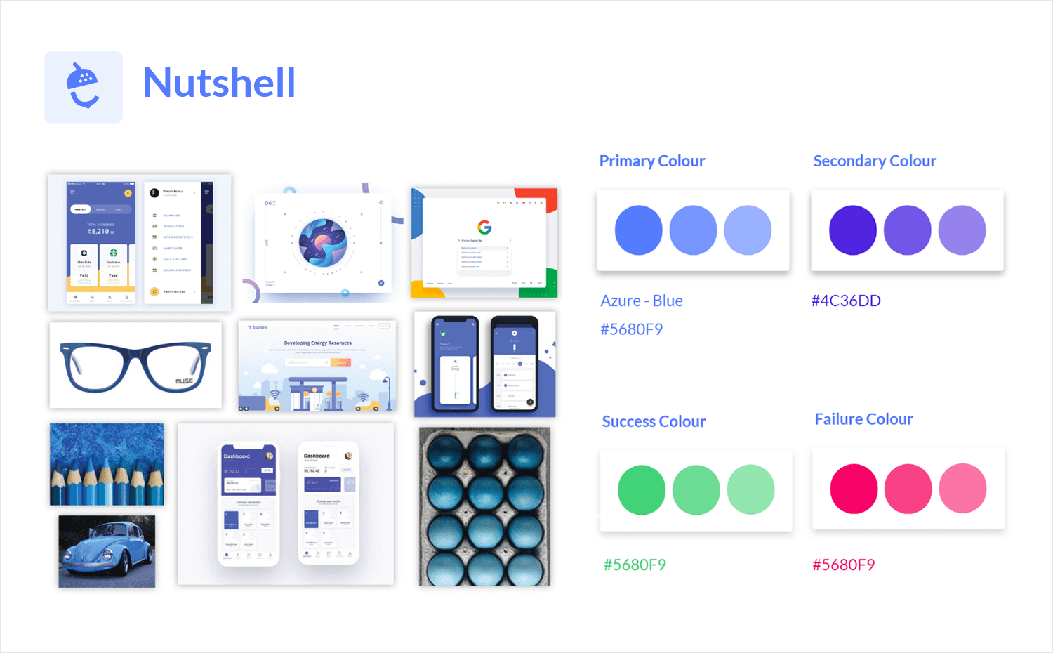

Figure 12: An example of a mood board[12]

### **3.2.2 Story Boards**

Using Adobe XD, creating storyboards gives a clear direction in terms of creating a fully functional application, how it will flow from each section and the full design aspect and how it can clearly work together. Creating storyboards will the developer to have a template of what the application is going to do, how it flows from one section to the other, and how to build the application itself. Inside the storyboard’s elements such as the design of a loading screen, main menu and progression menu will be displayed. With creative elements such as prototyping and designing features on Adobe XD, this allows designs of a storyboard to flow within a preview screen, showing the prototype process. The ability to flow to each page, replicating how the application would function once in its testing and launch phase, at the end of the project.

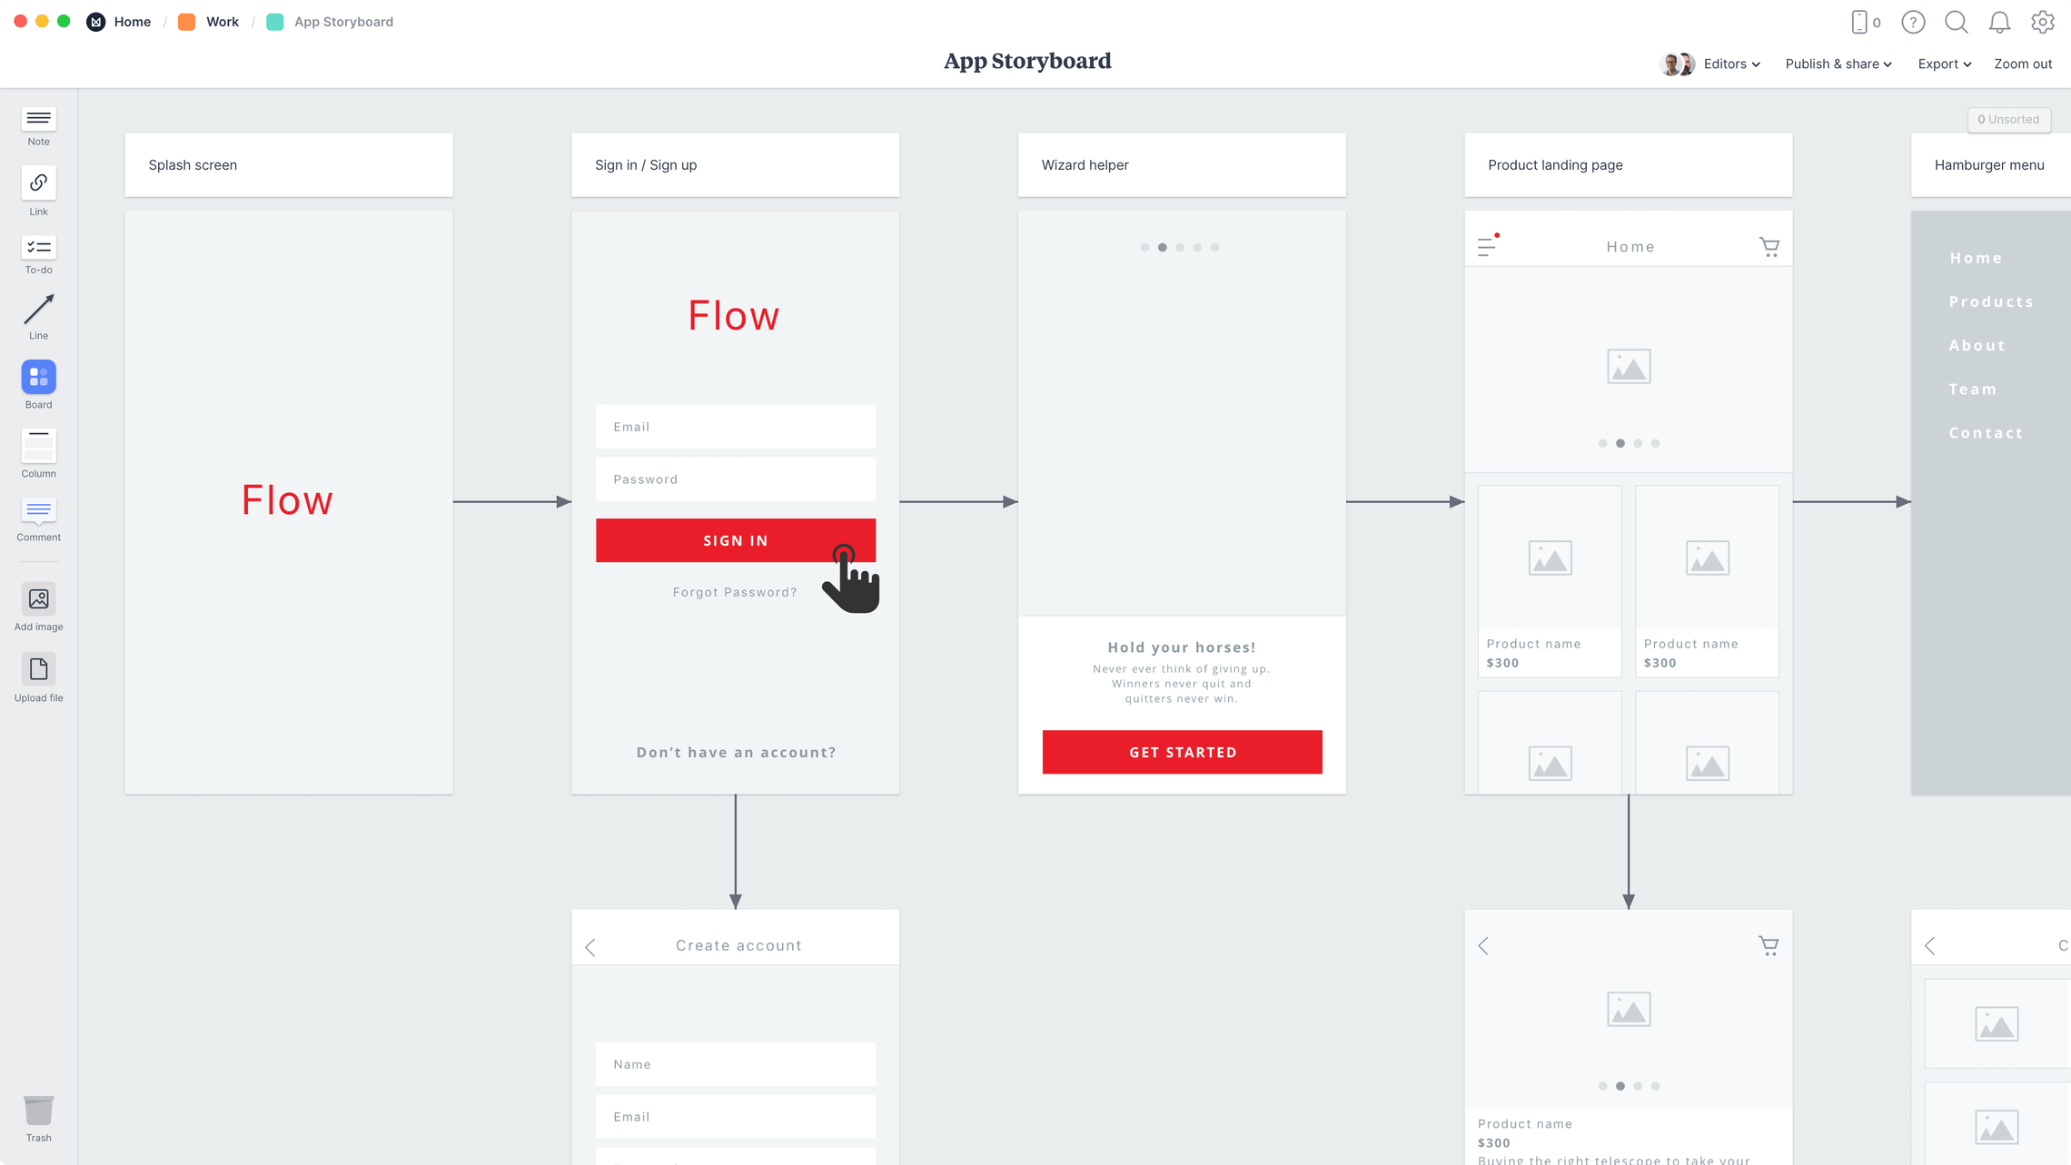

Figure 13: An example of a storyboard created for application development[13]

# **4. Background Information:**

## **4.1 Design Background**

During the project, design is key in creating any application, using a design and management plan will incorporate how the application will be built. To plan this project, Gantt charts are required to fully layout what will be achieved, with a short description of the task that will be completed, deadlines will be displayed for each section, and how long each task takes. This evidence will be backed up in the form of Weekly logs between personal tutor and student, and a Trello Board that will display ongoing assignments, upcoming plans, and additional information such as links to pipe band websites, applications or other online influences. As well as links to tutorials where required for each stage of the project. Using the software mentioned previously to effectively produce content throughout the project to incorporate into the bagpipe music theory application.

## **4.2 Practice Background**

During the final phase of the project, once the application has been completed, multiple testing requirements will be met to ensure the application meets its original requirements set in the Functional and Non-functional requirements documentation. The testing phase will require participants to test the application, due to the Covid pandemic applicants will be difficult to acquire, therefore forms such as data protection and consent forms must be completed before testing the application. Splitting up the testers into White Box (users who have knowledge in the application sector) and Black Box (users who have no knowledge in either application development or bagpipe music) testing, which multiple testing strategies will be implemented. These testing strategies include

* Using surveys, such as Survey Monkey, to get a general feel for the application;
* Usability testing is completing tasks based on the developer’s questions, such as complete a lesson;
* Function testing going through all elements of the application, ensuring that each button or link does its required function;
* General Feedback based on how the tester personally thought of the overall experience and possible recommendations.

## **4.3 Methodological Background**

The chosen methodology that will be incorporated into the project is Agile, focusing on the key components that allow the project to continuously develop. This methodology allows for the designer to continuously update the project plan accordingly if required by following the steps shown in Figure 14 below. These steps include

* Plan – In this section, all planning stages of the project are implemented, with objectives for each stage of the Agile cycle to achieve;
* Design – Creating all templates, documents and prototypes will be required in this stage of the Agile methodology;
* Develop – Implementing all the design aspects to create the application will be required in this section;
* Test – At each stage of development, any new function would be tested using the techniques discussed;
* Deploy – Within this stage, this would either add the new functions to the existing developed application which at this stage would be live in a testing phase;
* Review – At the end of each cycle all elements of the project would be evaluated and reflected, any unachieved work would be noted and if the project needed to repeat the stages, then the cycle would repeat;
* Launch – Once the application has met its requirements it will be complete and launched into the online market.

Each cycle will repeat if design or development changes, as this methodology focuses on quick and efficient work that can provide extensive feedback from clients and testers. These stages are reflected in the Gantt Chart as they main headings to highlight the importance of the project.

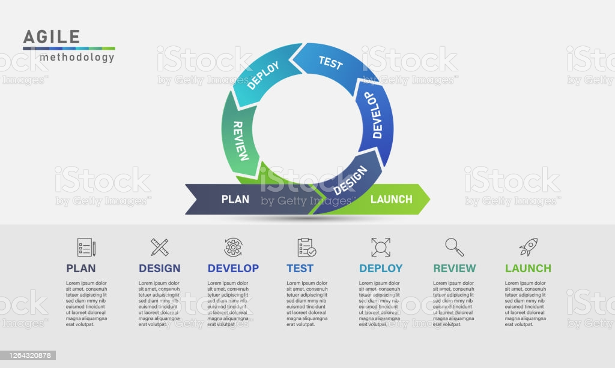

Figure 14: Agile Methodology[14]

## **4.4 Geographical Background**

Once the application is being developed and tested, to ensure that the accessibility requirements are met, the application needs to ensure that it can work as intended. After primary testing, the application can focus on ensuring accessibility requirements can be resolved (see Table 2). This approach will cover what accessibility requirements are needed, and how can these be resolved to ensure they are implemented into the application. Other components such as language translation will be implemented with the application automatically changing to the preferred student’s language.

|  |  |  |
| --- | --- | --- |
| Accessibility Requirements | Solution | When will this be implemented? |
| Zoom feature | Built in zoom feature where images can be enhanced if needed, as well as font size can be adjusted in settings. | Midway through project |
| Adjustable volume | Can be adjusted in the user’s settings | As soon as settings are created |
| Language | Create a button in the settings that allows this, also prompted in the main menu, showing ‘English’ or the selected language in the corner. | At the end of the development stage |
| Tutorials | Ongoing tutorials throughout the applications. A section will be available for all users to access at any time. | At the beginning of the development stage |

Table 2: Accessibility examples and its solutions

## **4.5 Literacy Background**

At the end of the project, a final report will be created evaluating the success and failures of the application. A summary will be provided listing any components or strategies within the application that were altered throughout the project, i.e.;

* Potential coding issues;
* Requirements not being met;
* Change in scope direction;
* Complications arounds converting bagpipe music notation into the digital form.

Backing up this evaluation and reflection document, evidence throughout the project will be gathered, and displayed through Trello boards, Gantt charts and Weekly logs as discussed above. The goal of the reflection and evaluation document at the end of the project is to see if the application answered the question, ‘Creating an intricate eLearning application in a Covid world: will bagpipe musical theory online revolutionise the global market for learning complex music notation?’.

# **5. Conclusion:**

Post-Covid, there has been a transition away from traditional learning techniques of the bagpipe. Instructors have been forced to teach remotely which has reduced the quality of teaching, particularly musical theory. There is currently no eLearning application available which covers music theory remotely. This literature review has identified a significant opportunity to create an application that allows students to learn complex bagpipe music theory without the need for one-to-one teaching in a safe environment. This concept can be expanded and possibly become a benchmark for other musical instruments as the world progresses towards a seemingly more digital and online world.

This project focuses on the creation of a Bagpipe Music Theory Application, the design process is key for its continual development. The software covered in this literature review is beneficial in creating an intricate application designed for a Covid world since this software is simple to use with free tutorials online that will provide clarity when designing and developing. In the application development phase, the software allows the developer to create an intricate application, exploring the themes that were covered in this literature, which in turn will create an interactive and engaging experience.

This literature review has created a dynamic overview of what is possible within the bagpipe industry, allowing for newer techniques to emerge as the push for more online orientated methods are in demand. Within this project, an application allowing students to learn music notation and Canntaireachd will be developed and will continuously test their knowledge. Continuing the passion to learn, inspire others to develop similar applications to advance the industry, connecting more people who need the support. With the creation of this application and the project has been completed, continual work of this application will continue to add more content and become more popular within the community. Sparking a new online development platform, growing the bagpipe world.

# **References:**

Adobe (2021) *Build buzz with sound effects* Available at: <https://www.adobe.com/products/audition/free-sound-effects.html> (Accessed: 19/11/2021)

Adobe (2021) *Media Encoder. Rock solid rendering* Available at: <https://www.adobe.com/products/media-encoder.html> (Accessed: 19/11/2021)

Alqahtani, A. Rajkhan, A. (2020) *E-Learning Critical Success Factors during the COVID-19 Pandemic: A Comprehensive Analysis of E-Learning Managerial Perspectives* [PDF] Available at: <https://www.mdpi.com/2227-7102/10/9/216> (Accessed: 19/11/2021)

Anima Documentation (2021) *Anima for Adobe XD* Available at: <https://docs.animaapp.com/v3/adobe-xd/getting-started/> (Accessed: 19/11/2021)

Azemovic, J. Music, D. (2010) *METHODS FOR EFFICIENT DIGITAL EVIDENCES COLLECTING OF BUSINESS PROCESES AND USERS ACTIVITY IN eLEARNING ENVIROMENTS* [PDF] Available at: <https://ieeexplore.ieee.org/abstract/document/5432370> (Accessed: 19/11/2021)

Bagpipe Lesson (2021) *Wings Bagpipe Sheet Music* Available at: <https://www.bagpipelesson.com/wings-bagpipe-sheet-music.html> (Accessed: 19/11/2021)

Baker, W. (2012) *E-LEARNING IN THE MUSIC AND VISUAL ARTS EDUCATION OF PRE-SERVICE TEACHERS: ACADEMIC PERSPECTIVES* [PDF] Available at: <https://www.researchgate.net/profile/William-Baker-6/publication/311430258_E-learning_in_the_music_and_visual_arts_education_of_pre-service_teachers_Academic_perspectives/links/58463a2508aeda69681a65fe/E-learning-in-the-music-and-visual-arts-education-of-pre-service-teachers-Academic-perspectives.pdf> (Accessed: 19/11/2021)

Barnes, J. (2006) *Bagpipe Music* [PDF] Available at: <https://link.springer.com/article/10.1007%2Fs11245-006-0002-5> (Accessed: 19/11/2021)

Bates, V.C. Talbot, B.C. Dyndahl, P. Karlsen, S. Wright, R. (2014) *Rethinking Cosmopolitanism in Music Education* [PDF] Available at: <http://citeseerx.ist.psu.edu/viewdoc/download?doi=10.1.1.695.8665&rep=rep1&type=pdf> (Accessed: 19/11/2021)

Beech, M. (2020) *COVID-19 Pushes Up Internet Use 70% And Streaming More Than 12%, First Figures Reveal* [Article] Available at: <https://www.forbes.com/sites/markbeech/2020/03/25/covid-19-pushes-up-internet-use-70-streaming-more-than-12-first-figures-reveal/> (Accessed: 19/11/2021)

Bevanda, V. Azemovic, J. Music, D. (2009) *Privacy preserving in eLearning environment (Case of modeling Hippocratic database structure)* [PDF] Available at: <https://ieeexplore.ieee.org/abstract/document/5359353> (Accessed: 19/11/2021)

Bissell, C. (2017) *Piobaireachd: The Classical Music Of The Great Highland Bagpipe* [Article] Available at: <https://corymbus.co.uk/piobaireachd-the-classical-music-of-the-great-highland-bagpipe/> (Accessed: 19/11/2021)

Buonvirl, N.O. Paney, A.S. (2015) *Melodic Dictation Instruction: A Survey of Advanced Placement Music Theory Teachers* [PDF] Available at: <https://journals.sagepub.com/doi/abs/10.1177/0022429415584141> (Accessed: 19/11/2021)

Crawford, R. (2016) *Rethinking teaching and learning pedagogy for education in the twenty-first century: blended learning in music education* [PDF] Available at: <https://www.tandfonline.com/doi/abs/10.1080/14613808.2016.1202223> (Accessed: 19/11/2021)

Cremata, R. Powell, B. (2017) *Online music collaboration project: Digitally mediated, deterritorialized music education* [PDF] Available at: <https://journals.sagepub.com/doi/abs/10.1177/0255761415620225> (Accessed: 19/11/2021)

Dias, C. (2021) *vscode.dev(!)* Available at: <https://code.visualstudio.com/blogs/2021/10/20/vscode-dev> (Accessed: 19/11/2021

Digolo, B.A. Andang’o, E.A. Katuli, J. (2011) *E- Learning as a Strategy for Enhancing Access to Music Education [PDF]* Available at: [http://www.ijbssnet.com/journals/Vol._2_No._11_[Special_Issue-June_2011]/19.pdf](http://www.ijbssnet.com/journals/Vol._2_No._11_%5bSpecial_Issue-June_2011%5d/19.pdf) (Accessed: 19/11/2021)

Downs, J. (2020) *Inspiring mood board examples* Available at: <https://www.justinmind.com/blog/mood-board-examples-design-website-app/> (Accessed: 19/11/2021)

Existek (2019) App Development Timeline: How Long Does It Take? [Article] Available at: <https://existek.com/blog/app-development-timeline-how-long-does-it-take/> (Accessed: 19/11/2021)

Gangaiamaran, R. Pasupathi, M. (2017) *Review on Use of Mobile Apps for Language Learning* [PDF] Available at: <http://www.ripublication.com/ijaer17/ijaerv12n21_102.pdf> (Accessed: 19/11/2021)

Godwin-Jones, R. (2011) *EMERGING TECHNOLOGIES MOBILE APPS FOR LANGUAGE LEARNING* [PDF] Available at: <https://scholarspace.manoa.hawaii.edu/bitstream/10125/44244/15_02_emerging.pdf> (Accessed: 19/11/2021)

Hebert, D.G. (2007) *FIVE CHALLENGES AND SOLUTIONS IN ONLINE MUSIC TEACHER EDUCATION* [PDF] Available at: <https://eric.ed.gov/?id=EJ814926> (Accessed: 19/11/2021)

Kim, D. (2021) *G Logo Design | Adobe Illustrator Tutorial* Available at: <https://www.behance.net/gallery/111328453/G-Logo-Design-Adobe-Illustrator-Tutorial> (Accessed: 19/11/2021)

Krueger, C.C. Lu, N. Swatman, P.M.C. (2003) *Success factors for online music marketing-eTransformation: from the four P's to the four C's* [PDF] Available at: <https://d1wqtxts1xzle7.cloudfront.net/41767181/Success_factors_for_online_music_marketi20160130-30347-1fr7kte-with-cover-page-v2.pdf?Expires=1637291848&Signature=WIR38oGMNJfoxeA9-x4tu1gtwdqsSVp4eBLD0QIrtagFKFP~hAcK2TYgzJeksh2eCUm9h3blPlWgD9h52UcZ8FZIyhYRumrbB8BOd9DjIRKLCahRObPL2nkrBRtJhW2mssawsBius4~igBMyVXV9jcIMAuTN4k7wzM25BmBeKrvhzNS91mk2qq5ur2ihlN0BZzbTpp~vAOIPM~Zyq2auCOVv8-cw42b1a4KZ4FxSuS4yuzupfiYulPCRwLl7w~wInb15oxF~hP~GxFlIixgYIHR7WCkSnZ4mssRYa0Hm5YM7pZUgfupgmM6E4fPL47G6RxRtTZ6SqRD7uCCrrIGrDg__&Key-Pair-Id=APKAJLOHF5GGSLRBV4ZA> (Accessed: 19/11/2021)

Linux Games (2021) *The Unity game engine already has a build for Linux* Available at: <https://www.linuxadictos.com/en/the-unity-game-engine-already-has-a-build-for-linux.html> (Accessed: 19/11/2021)

Ma, M. Oikonomou, A. (2017) *Serious Games and Edutainment Applications* [PDF] Available at: <https://link.springer.com/book/10.1007%2F978-3-319-51645-5> (Accessed: 19/11/2021)

McCalister, P. (2021) *Canntaireachd – an explanation by Peter McCalister* Available at: <https://www.piobaireachd.co.uk/archives/collection/canntaireachd-an-explanation> (Accessed: 19/11/2021)

McCombes, S. (2020) *How to write an abstract* Available at: <https://www.scribbr.co.uk/thesis-dissertation/abstract/> (Accessed: 19/11/2021)

Microsoft (2021) *Microsoft Word* Available at: <https://www.microsoft.com/en-us/microsoft-365/word> (Accessed: 19/11/2021)

Milanote (2021) *App Storyboard Template* Available at: <https://milanote.com/templates/storyboards/app-storyboard> (Accessed: 19/11/2021)

Regelski, T.A. (2013) *Music and Music Education: Theory and praxis for ‘making a difference’* [PDF] Available at: <https://www.tandfonline.com/doi/abs/10.1111/j.1469-5812.2005.00095.x> (Accessed: 19/11/2021)

Renee, V. (2018) *5 Nifty Tricks That Will Save You Time in Adobe After Effects* Available at: <https://nofilmschool.com/2018/01/5-nifty-tricks-will-save-you-time-adobe-after-effects> (Accessed: 19/11/2021)

Samhi, J. Allix, K. Bissyande, T.F. & Klein, J. (2021) *A first look at Android applications in Google Play related to COVID-19* [PDF] Available at: <https://link.springer.com/content/pdf/10.1007/s10664-021-09943-x.pdf> (Accessed: 19/11/2021)

Scherer, H. Winter, C. (2015) *Success factors for music-based crowdfunding as a new means of financing music projects* [PDF] Available at: <https://www.researchgate.net/profile/Carsten-Winter/publication/283295905_Success_factors_for_music-based_crowdfunding_as_a_new_means_of_financing_music_projects/links/563126b708ae506cea677530/Success-factors-for-music-based-crowdfunding-as-a-new-means-of-financing-music-projects.pdf> (Accessed: 19/11/2021)

Swan, V. (2007) *A STUDY INTO THE TEACHING OF THE SCOTTISH SMALLPIPES ON THE INTERNET USING PODCASTING AS A DISTRIBUTION MEDIUM* [PDF] Available at: <http://www.swan-dyer.co.uk/masters/Dissertation/VickiSwan-MastersDissertation.pdf> (Accessed: 19/11/2021)

Vlachos, P. Vrechopoulos, A. (2003) *Key Success Factors in the Emerging Landscape of Mobile Music Services* [PDF] Available at: <https://ieeexplore.ieee.org/abstract/document/1233869> (Accessed: 19/11/2021)

Wiggins, G. (1999) *Computers In Music Education* [PDF] Available at: <https://d1wqtxts1xzle7.cloudfront.net/1621993/1468en6g5c1m7p60-with-cover-page-v2.pdf?Expires=1637289770&Signature=I92MMNMse4MVWaA9v~lZNO3oWIFXDTl~0gfc9mn7~YSkzOvRsVRJZBMVqg7YUyoLvAj3iFfgsZTxQwDHsSiqHpp6E8VLLfgcglmh8n1m~QjWJ1kWIuu65MxnOB7cxw73-~63UFt2-UUklN2-Z3Ddu6R-fSU6W~hPH4ifTTpq8HplhQhZVK3CFpfMLcBsK7v7PQdlaGO3GIt7aGK9m2XRW5dV-c3wvodY2LgpWpadEM5eFcQIIoiLB29anDz4j772bT-DNUTudDTSoR7EkgW~1pWpF5XBxVaszfjZV7Cy3V5MyiyoSjtSaMTQ3wv3HuX3F0SxoSIaVwWuH8qiFlBI8w__&Key-Pair-Id=APKAJLOHF5GGSLRBV4ZA> (Accessed: 19/11/2021)

Ztaro (2020) *Agile development process infographic stock illustration* Available at: <https://www.istockphoto.com/vector/agile-development-process-infographic-gm1264320878-370268788> (Accessed: 19/11/2021)

1. Existek (2019) *App Development Timeline: How Long Does It Take?* [Article] Available at: <https://existek.com/blog/app-development-timeline-how-long-does-it-take/> (Accessed: 19/11/2021)
2. Bissell, C. (2017) *Piobaireachd: The Classical Music Of The Great Highland Bagpipe* [Article] Available at: <https://corymbus.co.uk/piobaireachd-the-classical-music-of-the-great-highland-bagpipe/> (Accessed: 19/11/2021)
3. McCalister, P. (2021) *Canntaireachd – an explanation by Peter McCalister* Available at: <https://www.piobaireachd.co.uk/archives/collection/canntaireachd-an-explanation> (Accessed: 19/11/2021)
4. Kim, D. (2021) *G Logo Design | Adobe Illustrator Tutorial* Available at: <https://www.behance.net/gallery/111328453/G-Logo-Design-Adobe-Illustrator-Tutorial> (Accessed: 19/11/2021)
5. Renee, V. (2018) *5 Nifty Tricks That Will Save You Time in Adobe After Effects* Available at: <https://nofilmschool.com/2018/01/5-nifty-tricks-will-save-you-time-adobe-after-effects> (Accessed: 19/11/2021)
6. Anima Documentation (2021) *Anima for Adobe XD* Available at: <https://docs.animaapp.com/v3/adobe-xd/getting-started/> (Accessed: 19/11/2021)
7. Adobe (2021) *Build buzz with sound effects* Available at: <https://www.adobe.com/products/audition/free-sound-effects.html> (Accessed: 19/11/2021)
8. Adobe (2021) *Media Encoder. Rock solid rendering* Available at: <https://www.adobe.com/products/media-encoder.html> (Accessed: 19/11/2021)
9. Linux Games (2021) *The Unity game engine already has a build for Linux* Available at: <https://www.linuxadictos.com/en/the-unity-game-engine-already-has-a-build-for-linux.html> (Accessed: 19/11/2021)
10. Dias, C. (2021) *vscode.dev(!)* Available at: <https://code.visualstudio.com/blogs/2021/10/20/vscode-dev> (Accessed: 19/11/2021
11. Microsoft (2021) *Microsoft Word* Available at: <https://www.microsoft.com/en-us/microsoft-365/word> (Accessed: 19/11/2021)
12. Downs, J. (2020) *Inspiring mood board examples* Available at: <https://www.justinmind.com/blog/mood-board-examples-design-website-app/> (Accessed: 19/11/2021)
13. Milanote (2021) *App Storyboard Template* Available at: <https://milanote.com/templates/storyboards/app-storyboard> (Accessed: 19/11/2021)
14. Ztaro (2020) *Agile development process infographic stock illustration* Available at: <https://www.istockphoto.com/vector/agile-development-process-infographic-gm1264320878-370268788> (Accessed: 19/11/2021)